**INDOOR LOCALIZATION**

**THE UNIVERSITY OF TEXAS AT ARLINGTON**

**EE6314-ADVANCED EMBEDDED MICROCONTROLLER SYSTEM**

**REPRESENTED BY RF TEAM**

**Submitted By-**

Vimal Vankar

Dhaval Padia

Disha Shah

Pooja Katiyar

Luv Sachdeva

Nihit Bhavsar

Anupama Malleshappa

Introduction

This paper represents the implementation of Indoor Localization, the goal of which is to find out the position of a mobile object in indoor areas. The project uses ultrasonic transmitter and receivers to determine that, the operating frequency of which is 24.2kHz. RF modules are used to provide the reference sync signal which operates at the frequency of 418MHz.

Interfacing Diagram

1. Reference Source

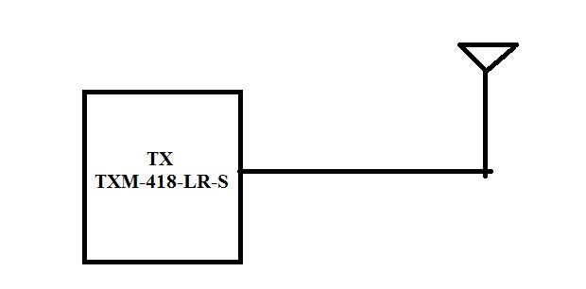

Figure.1: Transmitter block diagram

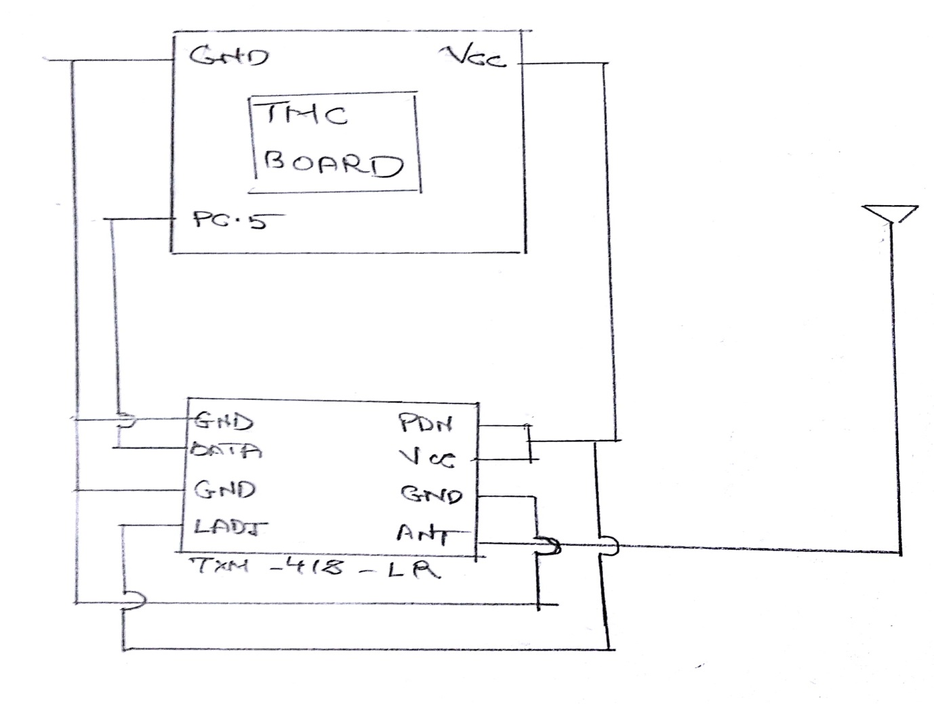 Figure.2: Transmitter Circuit diagram

The reference source uses TXM-418-LR RF module to transmit the sync signal and the data packet containing the information such as the room number, x, y and z location of the three beacons.

1. Ultrasonic Transmitters

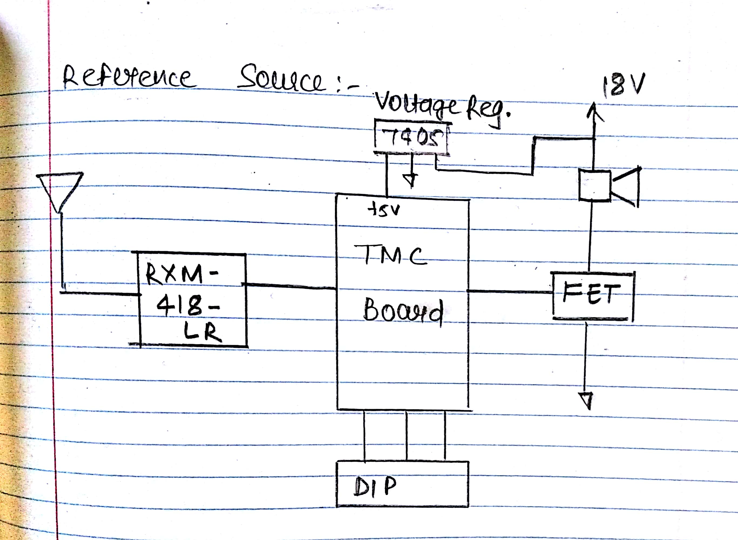

Figure.3: Ultrasonic transmitter block diagram

In ultrasonic transmitter, we used RXM-14-LR to receive the sync signal and applied the logic for sync detection. So, as soon as the sync is detected, according to the IDs of each beacon they will start transmitting. For generating the 24,.2 kHz square wave from microcontroller board, PWM is used which is used as the trigger to FET. Ultrasonic speakers are connected to FET in series with 18V power supply, this will result in to the square of 30 burst.

7405 voltage regulator is used in order to give constant 5V to the microcontroller board and 18V to the speaker.

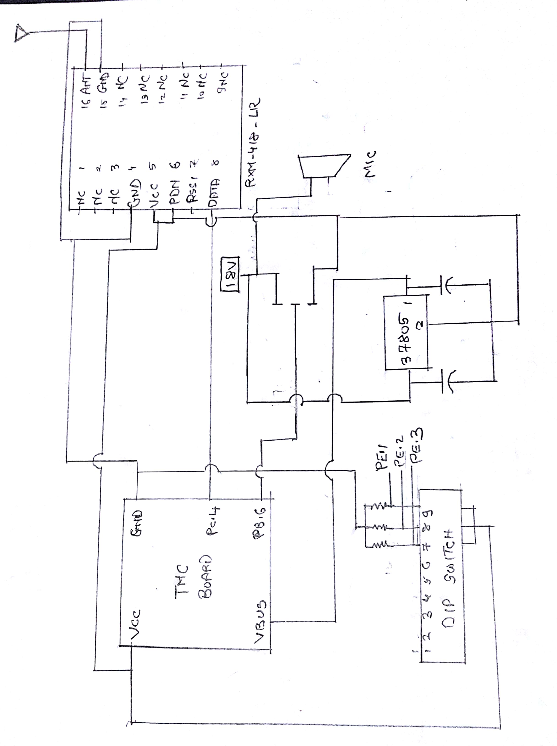

Figure 4: Ultrasonic Transmitter circuit diagram

Project Code-

1. **Reference source code (sync signal and data packets)**

|  |
| --- |
| **#include** <stdint.h>  **#include** <stdbool.h>  **#include** "tm4c123gh6pm.h"  **#include** <strings.h>  **#define** BLUE_LED (*((**volatile** uint32_t *)(0x42000000 + (0x400253FC-0x40000000)*32 + 2*4))) // on-board blue LED  **#define** X1_COOR 0  **#define** X2_COOR 496  **#define** X3_COOR 496  **#define** Y1_COOR 0  **#define** Y2_COOR 0  **#define** Y3_COOR 240  uint32_t sum;  uint8_t data[50];  **char** packet[256];  **void** **initHw**()  {  // Configure HW to work with 16 MHz XTAL, PLL enabled, system clock of 40 MHz  SYSCTL_RCC_R = SYSCTL_RCC_XTAL_16MHZ | SYSCTL_RCC_OSCSRC_MAIN | SYSCTL_RCC_USESYSDIV | (4 << SYSCTL_RCC_SYSDIV_S);  // Note UART on port C must use APB  SYSCTL_GPIOHBCTL_R = 0;  // Enable GPIO port A to F peripherals  SYSCTL_RCGC2_R = SYSCTL_RCGC2_GPIOA | SYSCTL_RCGC2_GPIOD | SYSCTL_RCGC2_GPIOE | SYSCTL_RCGC2_GPIOF | SYSCTL_RCGC2_GPIOB | SYSCTL_RCGC2_GPIOC;  // Configure port F  GPIO_PORTF_DIR_R = 0x04; // bits 2 is outputs for blue led  GPIO_PORTF_DR2R_R = 0x04; // set drive strength to 2mA (not needed since default configuration -- for clarity)  GPIO_PORTF_DEN_R = 0x04; // enable bit 2  // Configure UART1 pins  SYSCTL_RCGCUART_R |= SYSCTL_RCGCUART_R1; // turn-on UART1, leave other uarts in same status  GPIO_PORTC_DEN_R |= 0x30; // default, added for clarity  GPIO_PORTC_AFSEL_R |= 0x30; // default, added for clarity  GPIO_PORTC_PCTL_R |= GPIO_PCTL_PC5_U1TX | GPIO_PCTL_PC4_U1RX;  //UART1 CONFIGURATION  UART1_CTL_R = 0; // turn-off UART1 to allow safe programming  UART1_CC_R = UART_CC_CS_SYSCLK; // use system clock (40 MHz)  UART1_IBRD_R = 2083; // r = 40 MHz / (Nx115.2kHz), set floor(r)=21, where N=16 //1200 BUADRATE  UART1_FBRD_R = 21; // round(fract(r)*64)=45  UART1_LCRH_R = UART_LCRH_WLEN_8 | UART_LCRH_FEN; // configure for 8N1 w/ 16-level FIFO  UART1_CTL_R = UART_CTL_TXE | UART_CTL_RXE | UART_CTL_UARTEN; // enable TX, RX, and module  }  **void** **waitMicrosecond**(uint32_t us)  {  // Approx clocks per us  **__asm**("WMS_LOOP0: MOV R1, #6"); // 1  **__asm**("WMS_LOOP1: SUB R1, #1"); // 6  **__asm**(" CBZ R1, WMS_DONE1"); // 5+1*3  **__asm**(" NOP"); // 5  **__asm**(" B WMS_LOOP1"); // 5*3  **__asm**("WMS_DONE1: SUB R0, #1"); // 1  **__asm**(" CBZ R0, WMS_DONE0"); // 1  **__asm**(" B WMS_LOOP0"); // 1*3  **__asm**("WMS_DONE0:"); // ---  // 40 clocks/us + error  }  **void** **putcUart1**(**char** c)  {  **while** (UART1_FR_R & UART_FR_TXFF);  UART1_DR_R = c;  }  // Blocking function that writes a string when the UART buffer is not full  **void** **putsUart1**(**char**\* str)  {  uint8_t i;  **for** (i = 0; i < **strlen**(str); i++)  putcUart1(str[i]);  }  **void** **putcUart0**(**char** c)  {  **while** (UART0_FR_R & UART_FR_TXFF);  UART0_DR_R = c;  }  // Blocking function that writes a string when the UART buffer is not full  **void** **putsUart0**(**char**\* str)  {  uint8_t i;  **for** (i = 0; i < **strlen**(str); i++)  putcUart0(str[i]);  }  **void** **SumWords**(**void**\* data, uint16_t size_in_bytes)  {  uint8_t* pData = (uint8_t*)data;  uint16_t i;  uint8_t phase = 1;  uint16_t data_temp;  **for** (i = 0; i < size_in_bytes; i++)  {  **if** (phase)  {  data_temp = *pData;  sum += data_temp << 8;  }  **else**  sum += *pData;  phase = 1 - phase;  pData++;  }  }  // Completes 1's compliment addition by folding carries back uint8_to field  uint16_t **getChecksum**()  {  uint16_t result;  // this is based on rfc1071  **while** ((sum >> 16) > 0)  sum = (sum & 0xFFFF) + (sum >> 16);  result = sum & 0xFFFF;  **return** ~result;  }  **void** **initialize_data**()  {  data[0] = ((X1_COOR & 0xFF00) >> 8) + 1;  data[1] = (X1_COOR & 0x00FF) + 1;  data[2] = ((Y1_COOR & 0xFF00) >> 8) + 1;  data[3] = (Y1_COOR & 0x00FF) + 1;  data[4] = ((X2_COOR & 0xFF00) >> 8) + 1;  data[5] = (X2_COOR & 0x00FF) + 1;  data[6] = ((Y2_COOR & 0xFF00) >> 8) + 1;  data[7] = (Y2_COOR & 0x00FF) + 1;  data[8] = ((X3_COOR & 0xFF00) >> 8) + 1;  data[9] = (X3_COOR & 0x00FF) + 1;  data[10] = ((Y3_COOR & 0xFF00) >> 8) + 1;  data[11] = (Y3_COOR & 0x00FF) + 1;  data[12]='\0';  }  **int** **main**(**void**)  {  uint16_t chksum;  uint8_t i = 0;  uint8_t j = 0;  uint8_t len;  sum = 0;  initialize_data();  **char** *data_ptr = &data[0];  initHw();  BLUE_LED = 1;  waitMicrosecond(100000);  BLUE_LED = 0;  len = 12;  SumWords(data_ptr,len);  packet[i++] = len+2;  chksum = getChecksum();  **while**(j < len)  {  packet[i] = *data_ptr++;  i++;  j++;  }  packet[i++] = ((chksum & 0xFF00) >> 8) ;  packet[i++] = (chksum & 0x00FF);  packet[i] = '\0';  **while**(1)  {  BLUE_LED ^= 1;  UART1_DR_R = 0x41;  UART1_DR_R = 0x42;  UART1_DR_R = 0x43;  UART1_DR_R = 0x44;  UART1_DR_R = 0x45;  putsUart1(packet);  putsUart0(packet);  waitMicrosecond(250000);  }  } |

1. **Ultrasonic transmitter code (sync detection, checksum calculation and PWM generation)**

|  |
| --- |
| **#include** <stdint.h>  **#include** <stdbool.h>  **#include** "tm4c123gh6pm.h"  **#include** <strings.h>  **#define** BLUE_LED (*((**volatile** uint32_t *)(0x42000000 + (0x400253FC-0x40000000)*32 + 2*4))) // on-board blue LED  **#define** ORANGE_LED (*((**volatile** uint32_t *)(0x42000000 + (0x400043FC-0x40000000)*32 + 2*4))) // on-board blue LED  //pbs for ids  **#define** PUSHBUTTON1 (*((**volatile** uint32_t *)(0x42000000 + (0x400243FC-0x40000000)*32 + 1*4))) //  **#define** PUSHBUTTON2 (*((**volatile** uint32_t *)(0x42000000 + (0x400243FC-0x40000000)*32 + 2*4))) //  **#define** PUSHBUTTON3 (*((**volatile** uint32_t *)(0x42000000 + (0x400243FC-0x40000000)*32 + 3*4))) //  uint8_t seq_count=0;  bool sync_detected = false;  uint8_t data_len;  uint32_t sum;  **char** buffer[256];  **char** data[256];  uint8_t id;  **static** uint8_t k = 0;  uint8_t data_pos = 0;  uint32_t time_constant = 300000;  uint32_t delta_t;  bool data_r = false;  **char** sync_seq[6]={0x41,0x42,0x43,0x44,0x45};  uint16_t x1,y1,x2,y2,x3,y3;  **void** **initHw**()  {  // Configure HW to work with 16 MHz XTAL, PLL enabled, system clock of 40 MHz  SYSCTL_RCC_R = SYSCTL_RCC_XTAL_16MHZ | SYSCTL_RCC_OSCSRC_MAIN | SYSCTL_RCC_USESYSDIV | (4 << SYSCTL_RCC_SYSDIV_S);  // Note UART on port A must use APB  SYSCTL_GPIOHBCTL_R = 0;  // Enable GPIO port A to F peripherals  SYSCTL_RCGC2_R = SYSCTL_RCGC2_GPIOA | SYSCTL_RCGC2_GPIOD | SYSCTL_RCGC2_GPIOE | SYSCTL_RCGC2_GPIOF | SYSCTL_RCGC2_GPIOB | SYSCTL_RCGC2_GPIOC;  // Configure port F  GPIO_PORTF_DIR_R = 0x04; // bits 2 is outputs for blue led  GPIO_PORTF_DR2R_R = 0x04; // set drive strength to 2mA (not needed since default configuration -- for clarity)  GPIO_PORTF_DEN_R = 0x04; // enable bit 2  // Configure port F  GPIO_PORTA_DIR_R = 0x04; // bits 2 is output for sync_detection LED  GPIO_PORTA_DR2R_R = 0x04; // set drive strength to 2mA (not needed since default configuration -- for clarity)  GPIO_PORTA_DEN_R = 0x04; // enable bit 2  //Configure Port E for push buttons  GPIO_PORTE_DIR_R = 0x00;  GPIO_PORTE_DEN_R = 0x0E; // enable pushbuttons  GPIO_PORTE_PUR_R = 0x0E; // enable internal pull-up for push button  // Configure UART1 pins  SYSCTL_RCGCUART_R |= SYSCTL_RCGCUART_R1; // turn-on UART1, leave other uarts in same status  GPIO_PORTC_DEN_R |= 0x30; // default, added for clarity  GPIO_PORTC_AFSEL_R |= 0x30; // default, added for clarity  GPIO_PORTC_PCTL_R |= GPIO_PCTL_PC5_U1TX | GPIO_PCTL_PC4_U1RX;  //uart1  UART1_CTL_R = 0; // turn-off UART0 to allow safe programming  UART1_CC_R = UART_CC_CS_SYSCLK; // use system clock (40 MHz)  UART1_IBRD_R = 2083; // r = 40 MHz / (Nx115.2kHz), set floor(r)=21, where N=16  UART1_FBRD_R = 21; // round(fract(r)*64)=45  UART1_LCRH_R = UART_LCRH_WLEN_8; // configure for 8N1 w/o FIFO  UART1_CTL_R = UART_CTL_TXE | UART_CTL_RXE | UART_CTL_UARTEN; // enable TX, RX, and module  UART1_IM_R = UART_IM_RXIM; // turn-on RX interrupt  NVIC_EN0_R |= 1 << (INT_UART1-16); // turn-on interrupt 21 (UART0)  // PWM Configuration  SYSCTL_RCGCPWM_R |= SYSCTL_RCGCPWM_R0;  GPIO_PORTB_DEN_R |= 0xC0;  GPIO_PORTB_AFSEL_R |= 0xC0;  GPIO_PORTB_PCTL_R = GPIO_PCTL_PB6_M0PWM0;  PWM0_0_CTL_R = 0;  PWM0_0_GENA_R = PWM_0_GENA_ACTCMPAD_ZERO|PWM_0_GENA_ACTLOAD_M;  PWM0_0_LOAD_R = 0x674;  PWM0_0_CMPA_R = 0x33A;  PWM0_0_CTL_R |= 1;  PWM0_ENABLE_R |= PWM_ENABLE_PWM0EN;  }  **void** **waitMicrosecond**(uint32_t us)  {  // Approx clocks per us  **__asm**("WMS_LOOP0: MOV R1, #6"); // 1  **__asm**("WMS_LOOP1: SUB R1, #1"); // 6  **__asm**(" CBZ R1, WMS_DONE1"); // 5+1*3  **__asm**(" NOP"); // 5  **__asm**(" B WMS_LOOP1"); // 5*3  **__asm**("WMS_DONE1: SUB R0, #1"); // 1  **__asm**(" CBZ R0, WMS_DONE0"); // 1  **__asm**(" B WMS_LOOP0"); // 1*3  **__asm**("WMS_DONE0:"); // ---  // 40 clocks/us + error  }  **void** **sum_data**(**void**\* data, uint16_t size_in_bytes)  {  uint8_t* pData = (uint8_t*)data;  uint16_t i;  uint8_t phase = 1;  uint16_t data_temp;  **for** (i = 0; i < size_in_bytes; i++)  {  **if** (phase)  {  data_temp = *pData;  sum += data_temp << 8;  }  **else**  sum += *pData;  phase = 1 - phase;  pData++;  }  }  // Completes 1's compliment addition by folding carries back uint8_to field  uint16_t **getChecksum**()  {  uint16_t result;  // this is based on rfc1071  **while** ((sum >> 16) > 0)  sum = (sum & 0xFFFF) + (sum >> 16);  result = sum & 0xFFFF;  **return** ~result;  }  **void** **Uart1Isr**()  {  **char** in;  **static** uint8_t i=0;  in = UART1_DR_R;  **if**(sync_detected==true)  {  buffer[k] = in;  //data_pos = k;  k++;  **if**(k==buffer[0]+1)  {  data_r = true;  }  }  **if** (in == sync_seq[i] && sync_detected == false )  {  seq_count++;  i++;  **if**(seq_count == 5)  {  ORANGE_LED ^= 1;  sync_detected = true;  seq_count=0;  i=0;  k=0;  }  }  **else**  {  seq_count=0;  i=0;  }  }  // for id  **void** **readPbs**()  {  id = (PUSHBUTTON1<<2)|(PUSHBUTTON2<<1)|(PUSHBUTTON3);  }  **void** **decode_coordinates**()  {  x1 = ((((data[0] & 0xFF)-1) << 8) + ((data[1] & 0xFF)-1));  y1 = ((((data[2] & 0xFF)-1) << 8) + ((data[3] & 0xFF)-1));  x2 = ((((data[4] & 0xFF)-1) << 8) + ((data[5] & 0xFF)-1));  y2 = ((((data[6] & 0xFF)-1) << 8) + ((data[7] & 0xFF)-1));  x3 = ((((data[8] & 0xFF)-1) << 8) + ((data[9] & 0xFF)-1));  y3 = ((((data[10] & 0xFF)-1) << 8) + ((data[11] & 0xFF)-1));  }  **int** **main**(**void**)  {  initHw();  **static** **int** byte_count = 0;  BLUE_LED = 1;  waitMicrosecond(1000000);  BLUE_LED = 0;  **while**(1)  {  **if**(sync_detected==true && data_r == true)  {  data_len = buffer[0];  **for**(byte_count=0;byte_count<data_len;byte_count++)  {  data[byte_count]=buffer[byte_count+1];  }  **if**(byte_count == data_len)  {  data[byte_count] = '\0';  sum = 0;  sum_data(data,data_len);  **if**(getChecksum() == 0)  {  decode_coordinates();  BLUE_LED ^= 1;  readPbs();  delta_t = 100000 + id*time_constant;  waitMicrosecond(delta_t);  PWM0_ENABLE_R |= PWM_ENABLE_PWM0EN;  waitMicrosecond(1200);  PWM0_ENABLE_R &= ~PWM_ENABLE_PWM0EN;  }  sync_detected = false;  k=0;  data_r = false;  }  }  }  } |

Problems and Trouble Shooting:

ZigBee Modules:

Initially, we worked on ZigBee circuit and were able to transmit and receive the signals. But the problem regarding ZigBee module is at the receiving end. We observed that received signal was not in sync and was giving a delay of 40 microseconds at the receivers.

After discovering the delay, we tried to rectify the problem by switching from Zigbee to Linx-LR TX/RX modules.

RF modules:

After getting RF modules we first checked it for synchronization between the transmitted signal and respective received signal on the beacons. The delay between transmission and reception was approximately 55 microseconds and the delay between adjacent receivers was 1.5 microseconds. The delay between receivers was negligible and can be ignored.

Troubleshooting:

When we start understanding the circuit we came to know that our receiver was receiving garbage values whenever the transmitter wasn't transmitting. And so we implemented squall circuit by which we were able to eliminate the garbage values at the receiver.After that, the receiver was able to receive the correct signal but it was not able to detect between level zero and one as we applied the concept of preamble according to which we were giving a training sequence of 55..... in order to let receiver, decide between zero and one. By this method, we were able to receive correct data.

Contribution of Teammates

1. Vimal K Vankar

* Soldering Transmitter and Receiver RF Circuits.
* Testing transmitter and Receiver Circuits with the team.
* Check of RF modules for correct data reception and transmission- Software.
* Designing and experimenting different software for transmission and reception for RF modules.
* Design of software for ZigBee modules for transmission and reception check.
* Always Active to help team.

1. Luv Sachdeva

* Soldering of RF Modules.
* Configuration of Zigbee Modules.
* De-soldering of Zigbee Modules and RF modules whenever required.
* Setting up beacons and binding them appropriately.
* Debugging of sum calculation and checksum code.
* Debugging of hardware whenever occurred.

1. Anupama Malleshappa

* Worked with the team on Testing the RF Modules.
* Coding of RF Reference sync source with Pooja and Disha.
* Coding of RF message TX and RX code with checksum, sending coordinates and decoding it.
* Debugging when problems occurred at different stage with the team.
* Helped with entire team in final integration.

1. Nihit Bhavsar

* Last minute problem solving
* Coding Support
* Soldering and integration
* Configuring Zigbee modules

1. Dhaval Padia

* Designed FET circuit
* Soldering and integration
* Helped in configuring RF transmitter and receiver modules
* Worked with the team on testing the RF modules
* Dealing with issue of noise reception and testing squelch circuit for that issue
* Pole axis arrangement

1. Disha Shah

* Soldering of RF modules, FET and 7805 on gpb and zigbee modules
* Testing of zigbee module on XCTU as well as with code for data reception
* Testing of delays between RF transmitter and receiver and receiver to receiver
* Checking the range and sync signal on oscilloscope for RF and zigbee modules
* Dealing with issue of noise reception and testing squelch circuit for that issue
* Debugging and solving hardware issues
* Testing rf modules output, range by integrating ultrasonic receiver circuit and debugging rf tx and Rx code for different burst cycles and sync timings
* Helped in software for sending location (x,y,z coordinates) from reference source and decoding it on ultrasonic transmitter side

1. Pooja Katiyar

* Zigbee configuration using XCTU and AT commands
* Checking the delay time between transmission and reception of zigbees
* Interfacing Ultrasonic transmitter with microcontroller using FET
* Configuration of RF modules and testing it for the maximum delay between transmission and reception and for different receivers.
* Dealing with issue of noise reception and testing squelch circuit for that issue
* Coding of RF TX and RX code for sync detection and checksum calculation
* Debugging and troubleshooting hardware and software issues
* Integration of all modules and testing the ultrasonic transmitter for different burst